[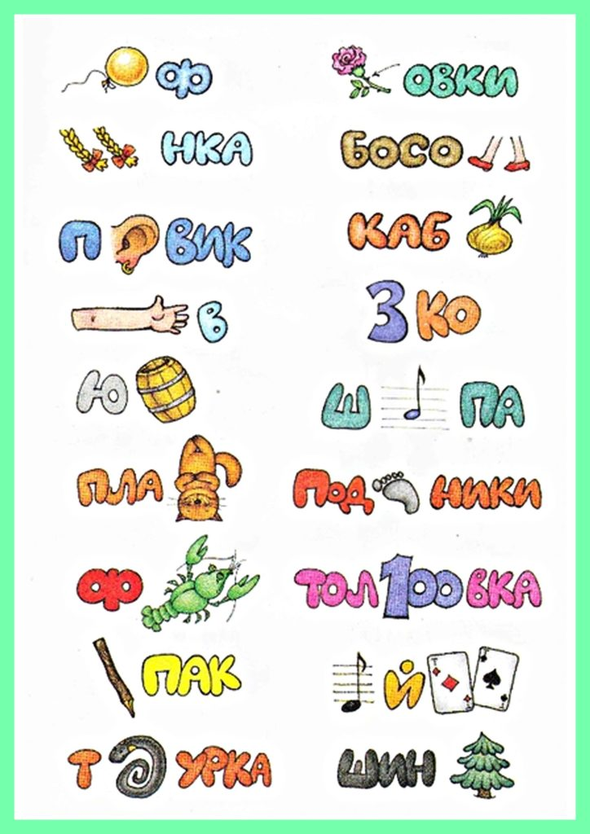](https://novye-multiki.ru/wp-content/uploads/2020/03/rebus.jpg)

[](https://novye-multiki.ru/wp-content/uploads/2020/03/rebus2.jpg)

[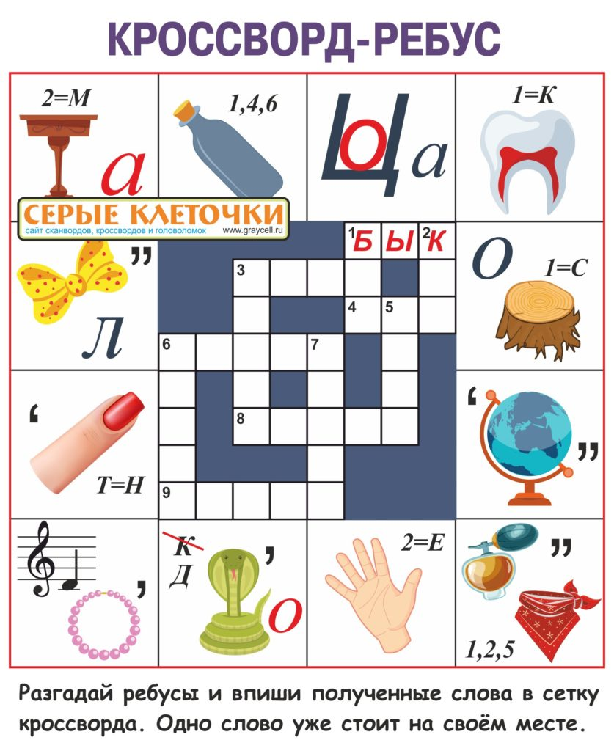](https://novye-multiki.ru/wp-content/uploads/2020/03/rebus3.jpg)

[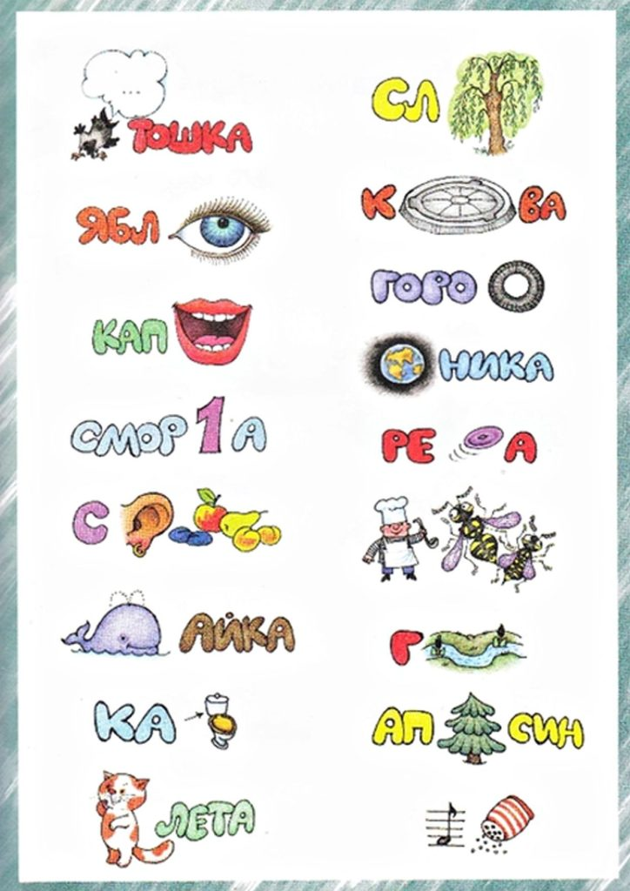](https://novye-multiki.ru/wp-content/uploads/2020/03/rebus4.jpg)